**Test case one**

/* Test Case One

< 10 lines */

/* Function definition disabled for assignment 3 */

@@

int a, b, c;

boolean one, two;

int x;

@@

while( a < b) a:= b + c;

x := c + b * a;

y := a * b;

**Result:**

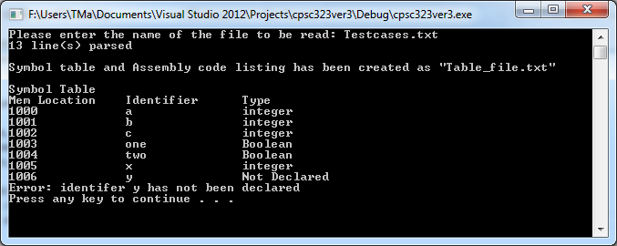

**File generated for test case one:**

Symbol Table

Mem Location Identifier Type

1000 a integer

1001 b integer

1002 c integer

1003 one Boolean

1004 two Boolean

1005 x integer

1006 y Not Declared

**Test case two**

/* Test Case One < 20 lines */

/* Function definition disabled for assignment 3 */

@@

int a, b, c;

boolean one, two;

int x;

@@

while( a < b) a:= b + c;

x := c + b * a;

read (one, two);

while( a != b)

{

write(b);

}

**Result of test case two:**

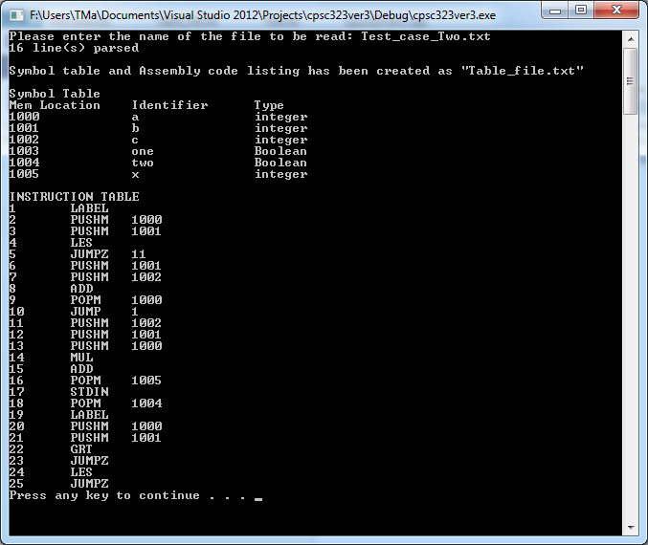

**File generated for test case two:**

Symbol Table

Mem Location Identifier Type

1000 a integer

1001 b integer

1002 c integer

1003 one Boolean

1004 two Boolean

1005 x integer

INSTRUCTION TABLE

1 LABEL

2 PUSHM 1000

3 PUSHM 1001

4 LES

5 JUMPZ 11

6 PUSHM 1001

7 PUSHM 1002

8 ADD

9 POPM 1000

10 JUMP 1

11 PUSHM 1002

12 PUSHM 1001

13 PUSHM 1000

14 MUL

15 ADD

16 POPM 1005

17 STDIN

18 POPM 1004

19 LABEL

20 PUSHM 1000

21 PUSHM 1001

22 GRT

23 JUMPZ

24 LES

25 JUMPZ

**Test case three**

/* Test Case Three > 20 lines */

/* Function definition disabled for assignment 3 */

@@

int a, b, c;

boolean one, two;

int x;

int i, max, sum;

@@

if (a<b) a:= c; else c:= a+b; endif

while (i < max) i := i + 1;

read(max);

while(i<max){

i:=i+1;

}

write (sum+max);

sum := 0;

read (one, two);

while(a>c)

{

write (two);

}

if (c != b) a:=b; endif

**Result of test case three:**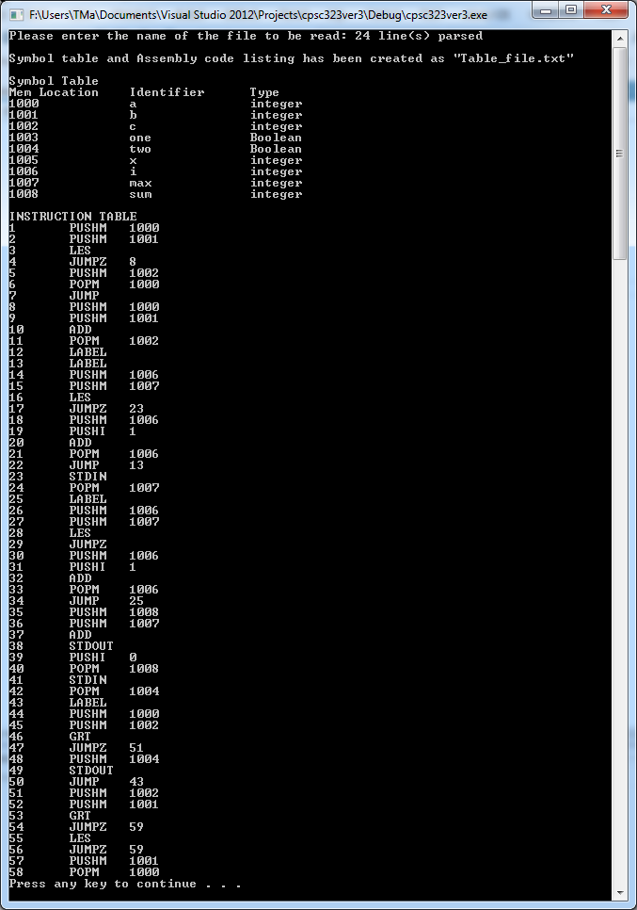

**File generated for test case three:**

Symbol Table

Mem Location Identifier Type

1000 a integer

1001 b integer

1002 c integer

1003 one Boolean

1004 two Boolean

1005 x integer

1006 i integer

1007 max integer

1008 sum integer

INSTRUCTION TABLE

1 PUSHM 1000

2 PUSHM 1001

3 LES

4 JUMPZ 8

5 PUSHM 1002

6 POPM 1000

7 JUMP

8 PUSHM 1000

9 PUSHM 1001

10 ADD

11 POPM 1002

12 LABEL

13 LABEL

14 PUSHM 1006

15 PUSHM 1007

16 LES

17 JUMPZ 23

18 PUSHM 1006

19 PUSHI 1

20 ADD

21 POPM 1006

22 JUMP 13

23 STDIN

24 POPM 1007

25 LABEL

26 PUSHM 1006

27 PUSHM 1007

28 LES

29 JUMPZ

30 PUSHM 1006

31 PUSHI 1

32 ADD

33 POPM 1006

34 JUMP 25

35 PUSHM 1008

36 PUSHM 1007

37 ADD

38 STDOUT

39 PUSHI 0

40 POPM 1008

41 STDIN

42 POPM 1004

43 LABEL

44 PUSHM 1000

45 PUSHM 1002

46 GRT

47 JUMPZ 51

48 PUSHM 1004

49 STDOUT

50 JUMP 43

51 PUSHM 1002

52 PUSHM 1001

53 GRT

54 JUMPZ 59

55 LES

56 JUMPZ 59

57 PUSHM 1001

58 POPM 1000